**Rosanna Cubs –**



**Greensborough RSL**

**Tuesday 14th June**

This Tuesday, the 14th, we’re going to meet at Greensborough RSL to learn about “Their Service – Our Heritage” as part of earning the Heritage Badge.

Details:

* Meet at Greensborough RSL, 111 Main St, Greensborough (see map) **before 7 pm.**

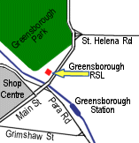

* Pickup from the RSL at the conclusion at **8:30pm** (approx).

Cubs will be learning about the service of our Service men and women….. and if we’re lucky, they might even feed us something! For those who also attended Anzac Day Services, these will complete their Heritage Badge requirements. For others, this will cover half the badge and we can sort out the requirements for the rest.



Note: parking is limited.

See you there – don’t miss it!

# 